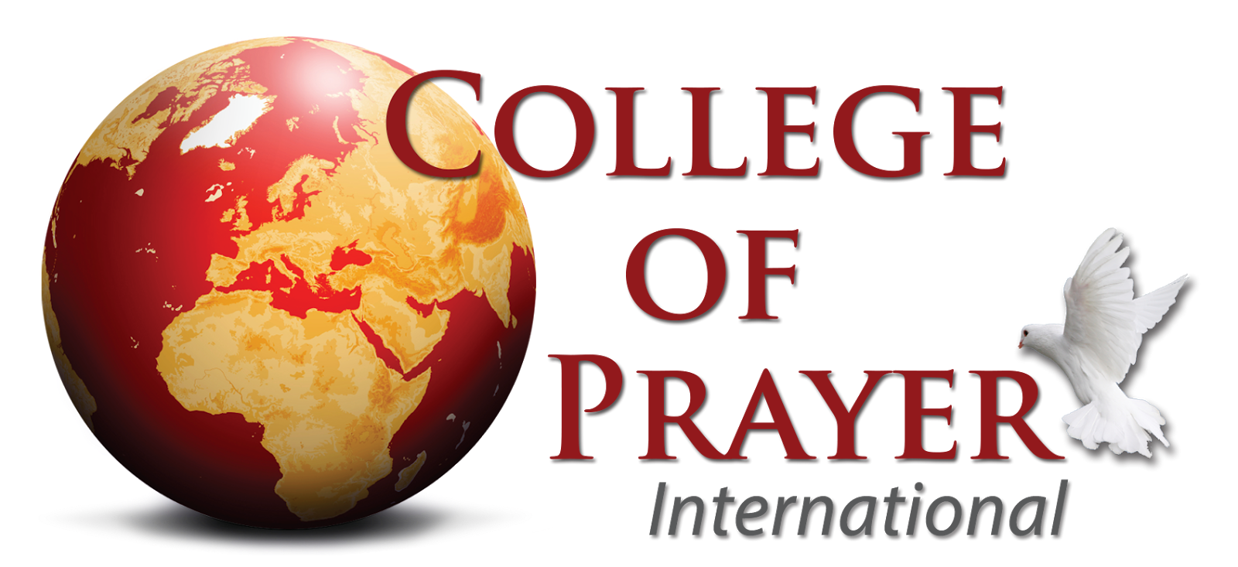

Campus Location:
Date:
Name and Position of Person Submitting Report:

The purpose of this report is for accountability and accreditation. Please note the reference to sections in the College of Prayer Manual for further clarification. The completion of the Annual Accreditation Report Form is required for your continued certification as a College of Prayer campus.

1. Names and positions of all members of your Servant Leadership Team? (Section II)

2. What other support people and positions serve in your campus? (Section II)

3. How did you lead in an “Upper Room” encounter with God at your module? (Section V) What were the signs of Christ’s manifest presence? Be specific (i.e., level of worship, genuine repentance, etc.)

4. How are you employing the Fullness and Fulfillment format in your Modules? (Section I) Give specific examples.
a. Fullness - receiving personal revival.
b. Fulfillment - releasing God’s Spirit through us and the extension of Christ’s kingdom.

5. How did you include the three critical elements of instruction, intercession and interaction? (Section II B) Approximately what percentage of time was given to each emphasis? (This should add up to 100%)
a. Instruction:
b. Interaction (GAP Groups):
c. Intercession:

6. Each year a different theme has been picked for a special emphasis. Year 1 “Lord, Teach us to Pray”; Year 2 “Lord, as Families, Teach Us to Pray”; and Year 3 “Lord, as Churches, Teach us to Pray.” How have you incorporated these? What was your emphasis this year? Are you using the coinciding notebooks?

7. How many students did you certify this year? Approximately how many students will be certified next year? (Section IV C)

8. How many students are currently enrolled and attending your College of Prayer campus?

9. What are some stories of transformation in lives of attendees?

10. What campuses do you anticipate planting in the next year or two?

