Join churches from around Atlanta for the next gathering of the College of Prayer, June 14-16, at New Mercies Christian Church! The topic will be “Lord, Teach Us to Pray!”

HEAR relevant teaching from some of Atlanta’s most respected pastors including Jesse Curney of New Mercies, Fred Hartley of Lilburn Alliance and Richard Haynes of Salem Missionary Baptist.

EXPERIENCE powerful God-encountering prayer, high worship and spiritual renewal. LEARN to pray like Jesus. FELLOWSHIP with others from around the city. All are welcome to come! Don’t miss this opportunity to unify our churches around Atlanta and experience personal and corporate revival as we seek God’s heart for our lives, our families, our churches and our city.
Join churches from around Atlanta for the next gathering of the College of Prayer, June 14-16, at New Mercies Christian Church! The topic will be “Lord, Teach Us to Pray!”

HEAR relevant teaching from some of Atlanta’s most respected pastors including Jesse Curney of New Mercies, Fred Hartley of Lilburn Alliance and Richard Haynes of Salem Missionary Baptist.

EXPERIENCE powerful God-encountering prayer, high worship and spiritual renewal. LEARN to pray like Jesus. FELLOWSHIP with others from around the city. All are welcome to come! Don’t miss this opportunity to unify our churches around Atlanta and experience personal and corporate revival as we seek God’s heart for our lives, our families, our churches and our city.

Schedule for June 14-16:
Thursday, 6:30 PM - 9 PM
Friday, 9 AM - 8:30 PM
(lunch & dinner included)
Saturday, 9 AM - 12 PM
Cost:
$35
Location:
New Mercies Christian Church 4000 Five Forks Trickum Rd.
Lilburn, GA 30047
(770) 925-8600
Schedule for June 14-16:
Thursday, 6:30 PM - 9 PM
Friday, 9 AM - 8:30 PM
(lunch & dinner included)
Saturday, 9 AM - 12 PM
Cost:
$35
Location:
New Mercies Christian Church 4000 Five Forks Trickum Rd.
Lilburn, GA 30047
(770) 925-860
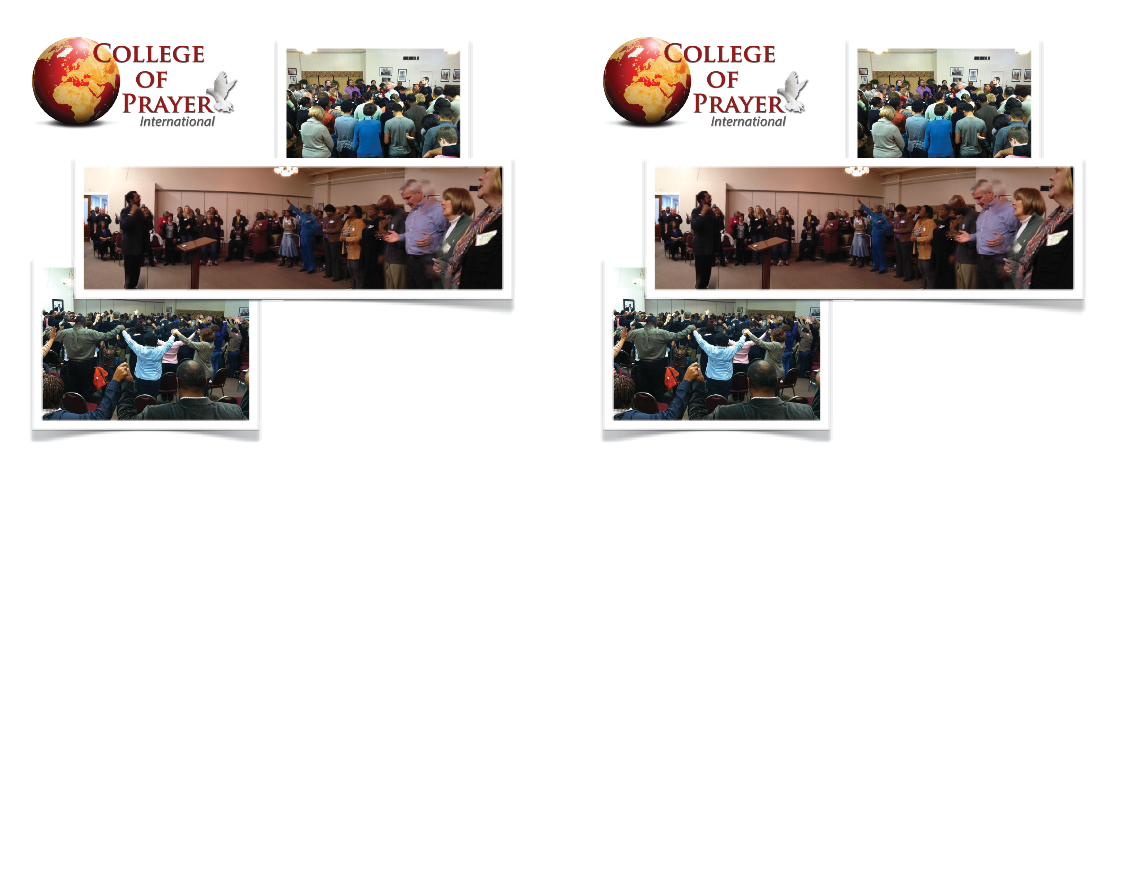The College of Prayer International has trained over 200,000 Christian leaders around the world and has over 600 campuses in 42 countries.
To learn more, visit collegeofprayer.org/events or call 770-829-0122!
The College of Prayer International has trained over 200,000 Christian leaders around the world and has over 600 campuses in 42 countries.
To learn more, visit collegeofprayer.org/events or call 770-829-0122!

